Windows server lab

1-1 and 1-2

1. The purpose of this lab was to demonstrate how to view currently running processes
2. The lab had me open server manager and view the current version of Windows Server that was installed. It also had me view currently running processes in windows server.
3. I used server manager to complete this.
4. 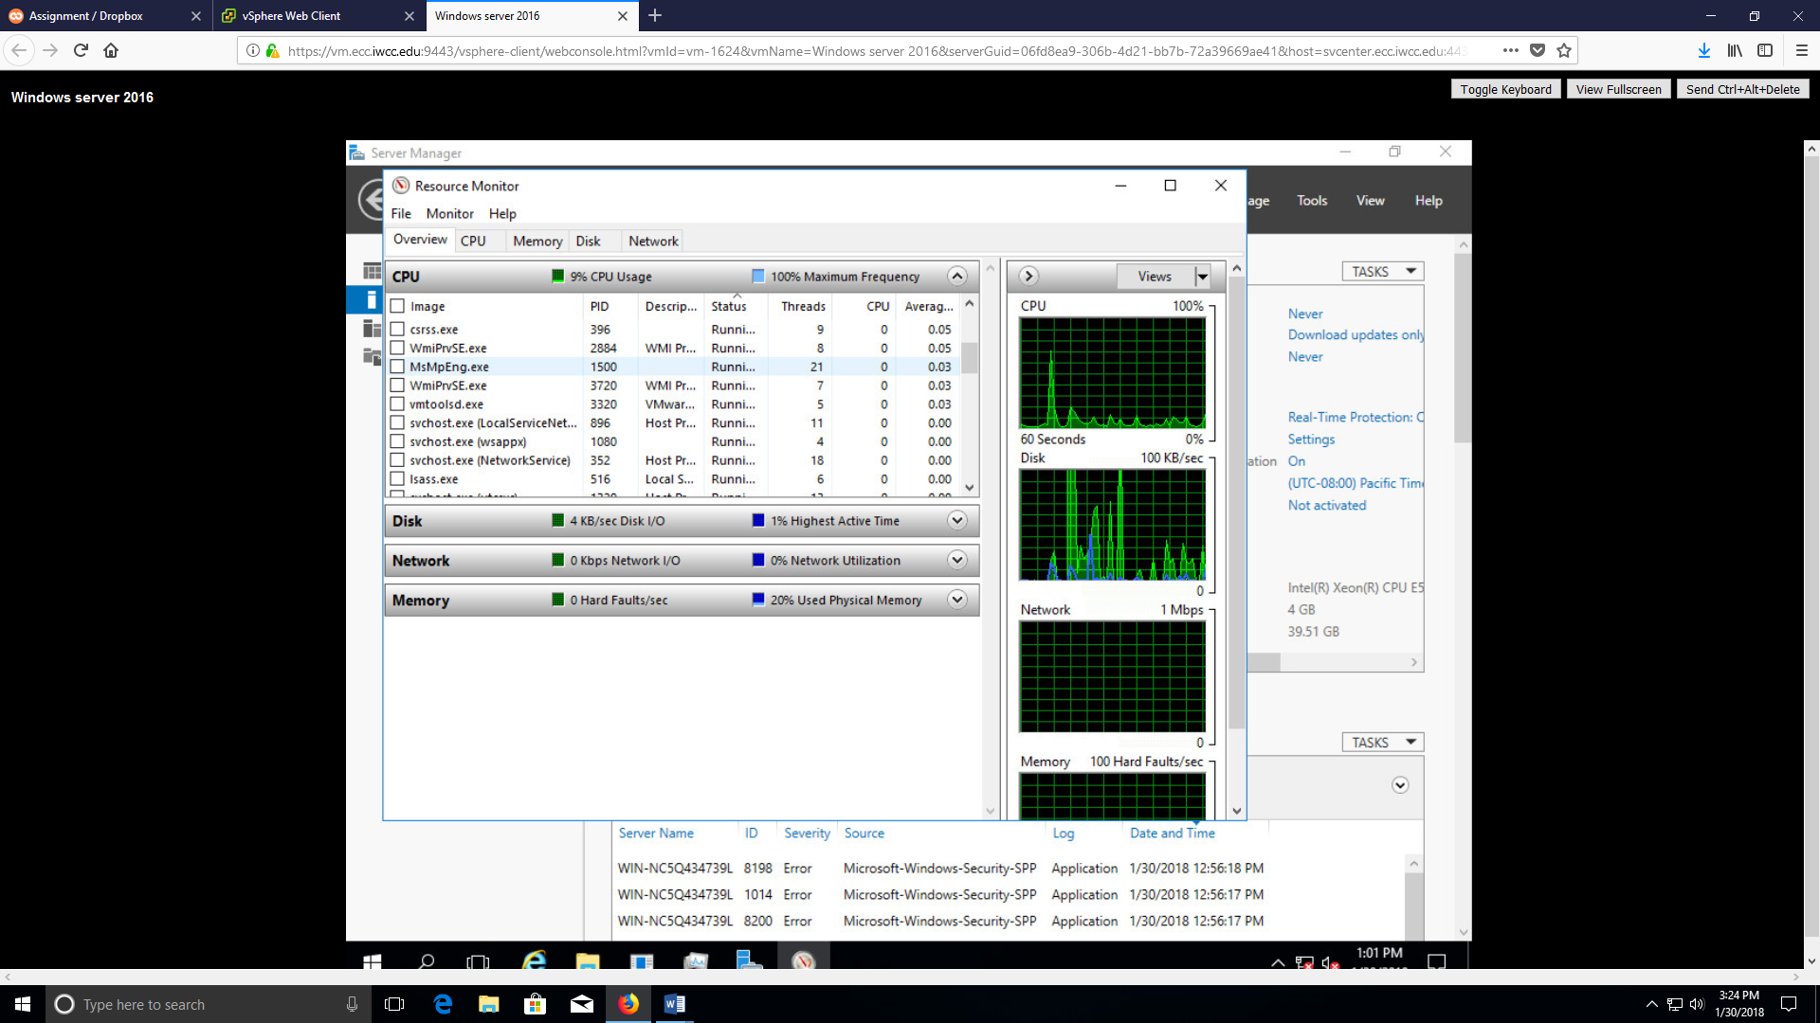

1-7

1. The purpose of this lab was to teach me how to configure an ip address in windows server.
2. The lab had me configure the ip address in server manager.
3. I used server manager to configure the ip address
4. 